1. **Design a professional resume using templates.**

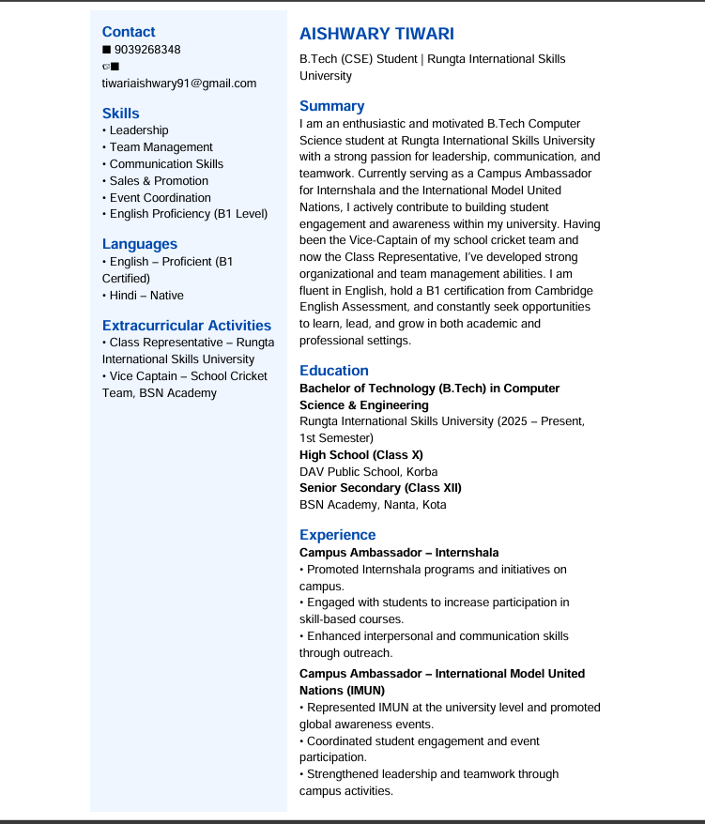

1. **Create a Career Oriented Presentation with 7 slides using transitions and animations.**

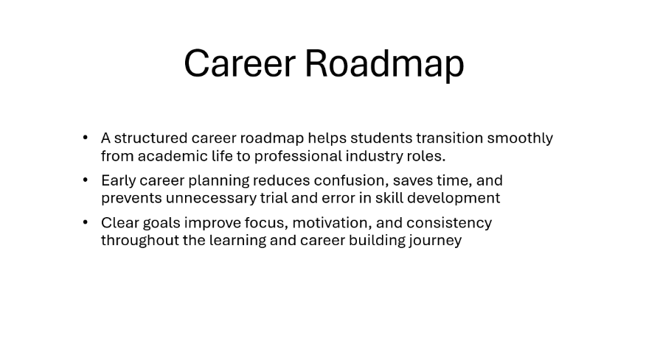

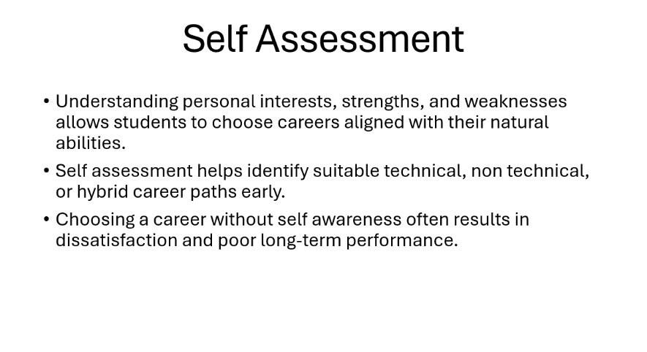

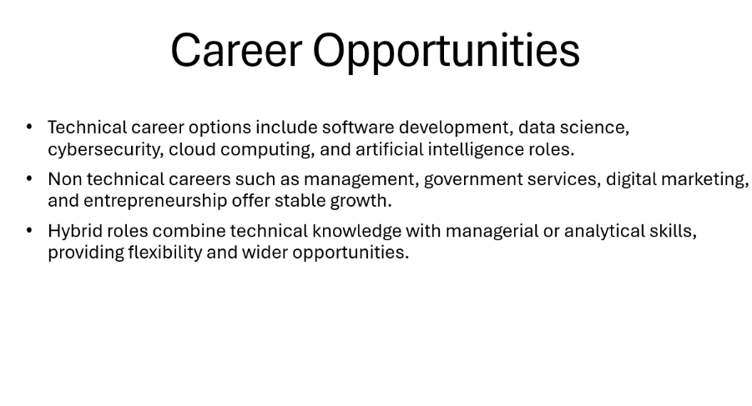

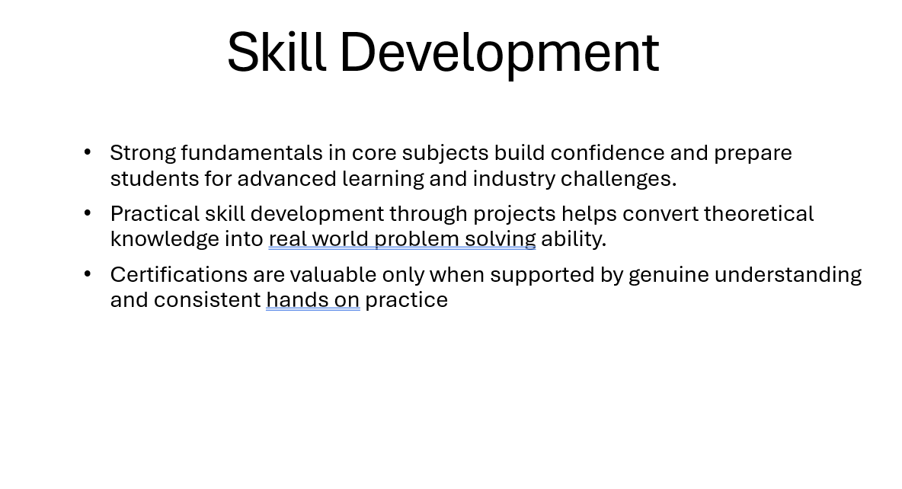

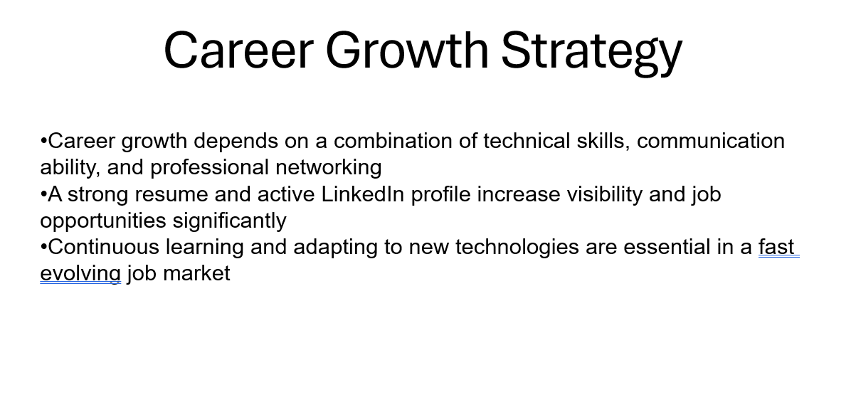

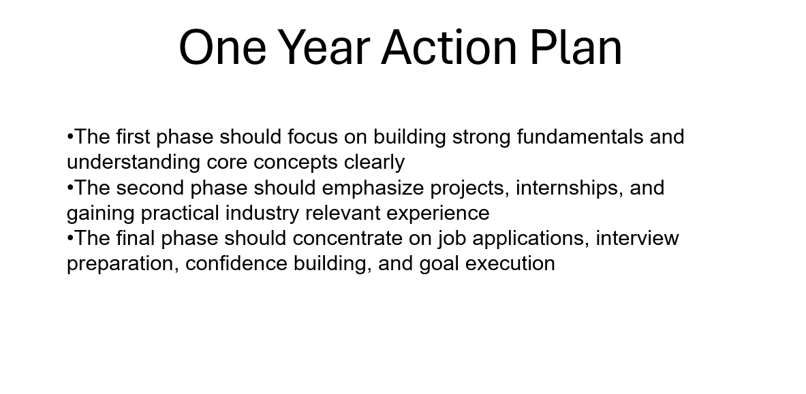

1. **Create a social media poster for “DIGITAL AWARENESS WEEK” using canva.**

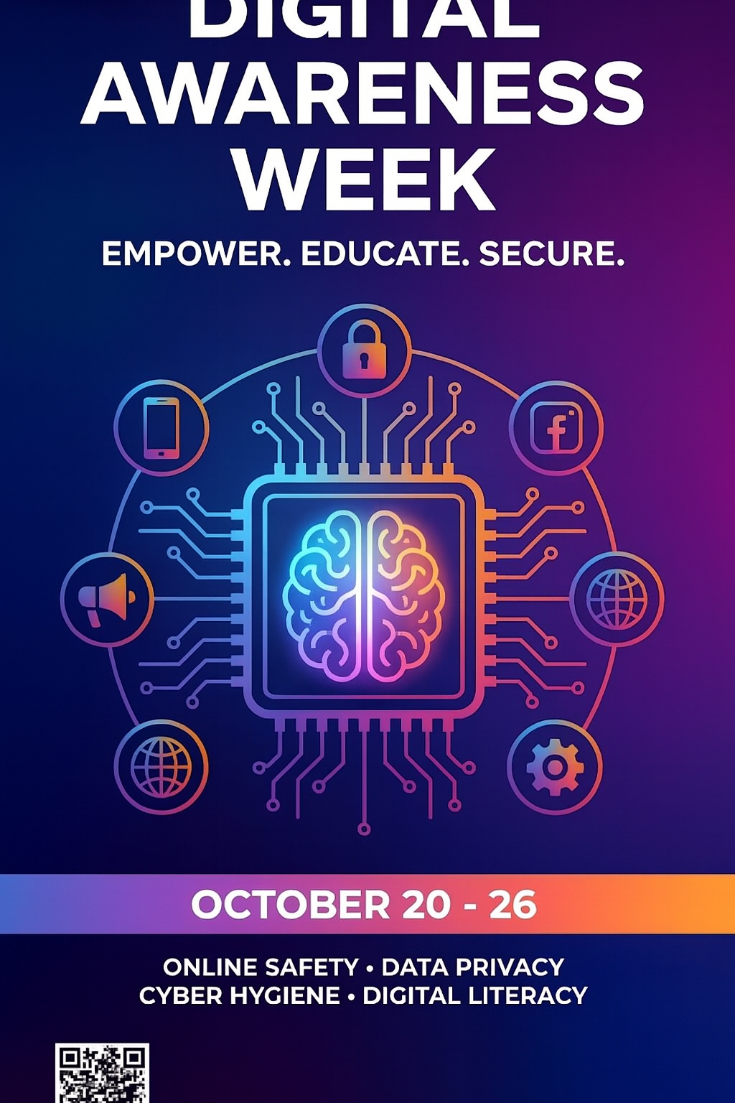

1. **Compose s send a professional email with an attachment as “you are applying for an internship, send email to HR with your resume attached”.**

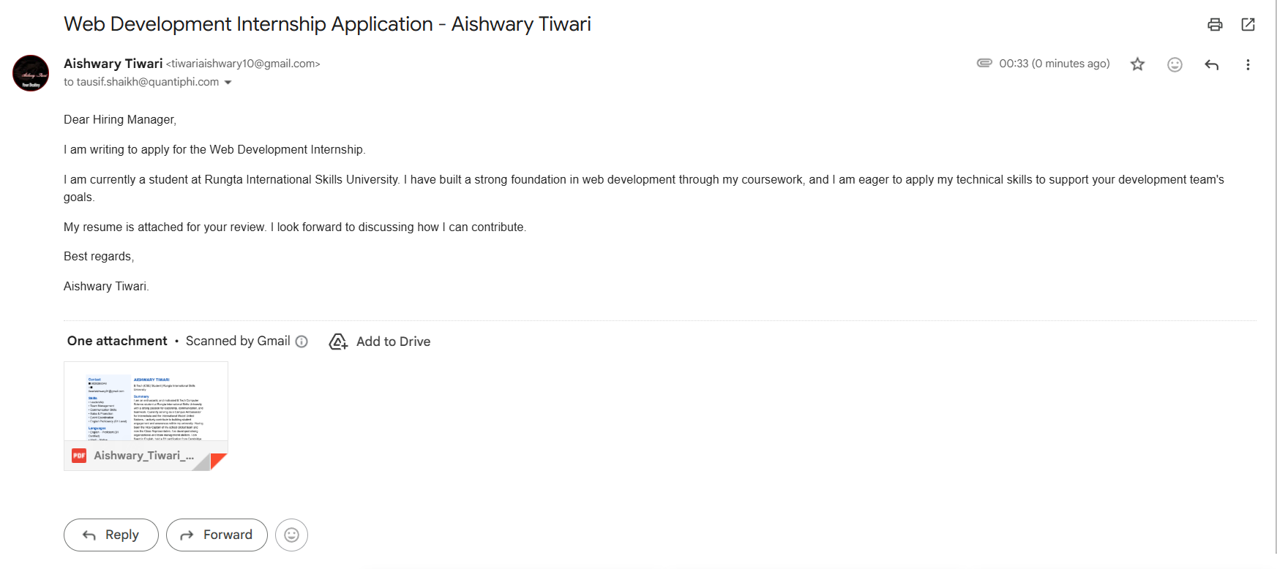

1. **Design a complete Google Form survey and analyze responses.**
   1. Create a Google Form titled “Student Attendence Report”.
   2. Include the following question types:

a. 5 MCQs

* + 1. Rating scale (1–5)
  1. Short answer
  2. Checkbox question
  3. Customize the theme (header image + color).
  4. Share the form link with 5 friends and collect responses.
  5. Generate charts from responses and take screenshots of the analysis page.

**The form looks like this:**

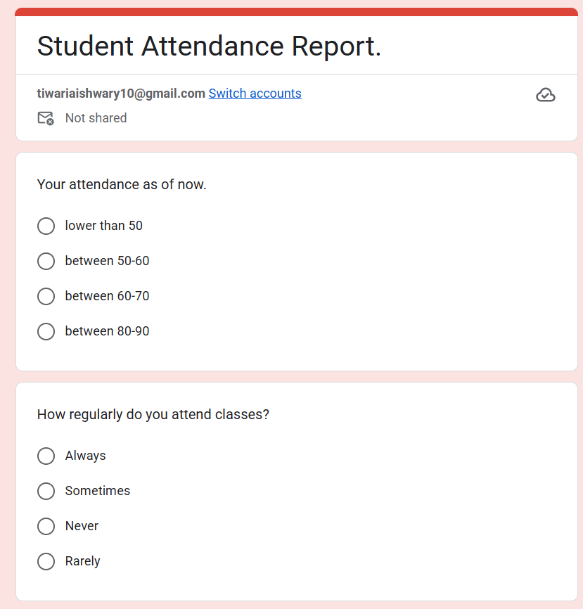

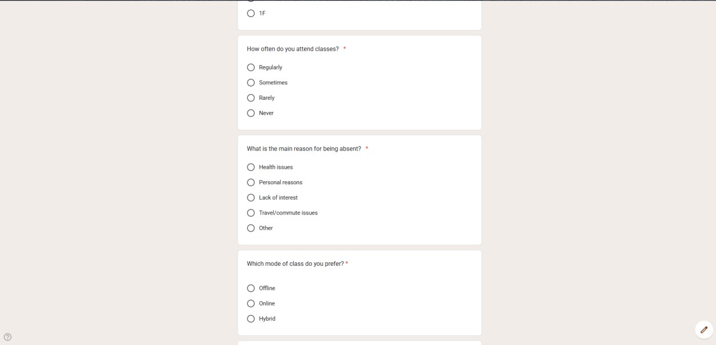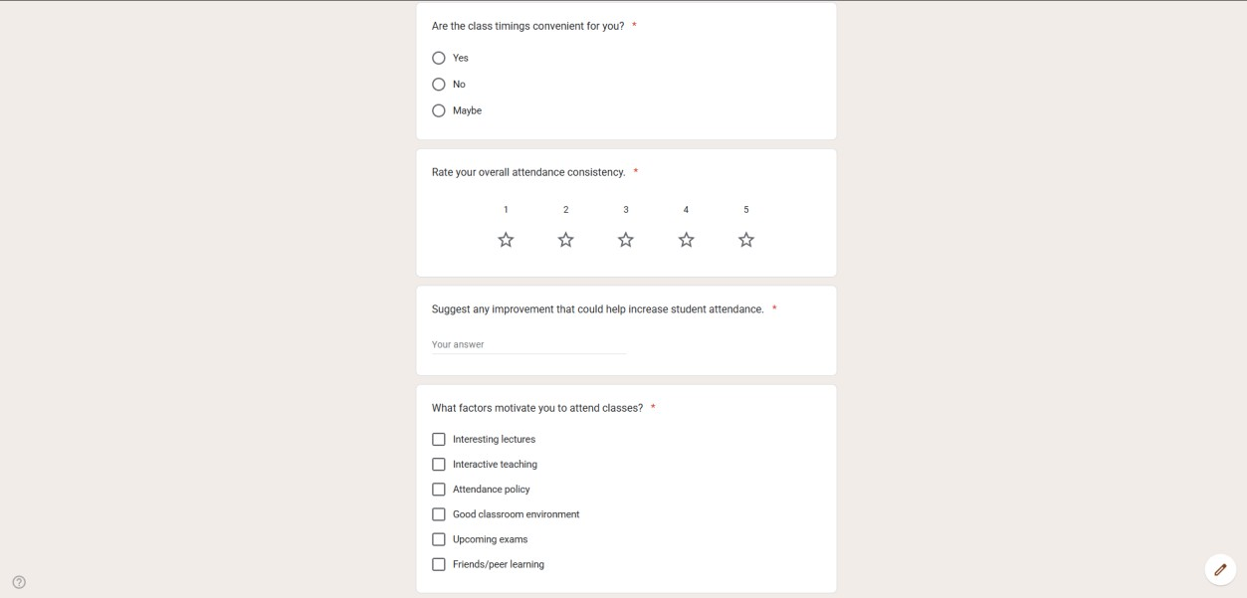

**The Response charts:**

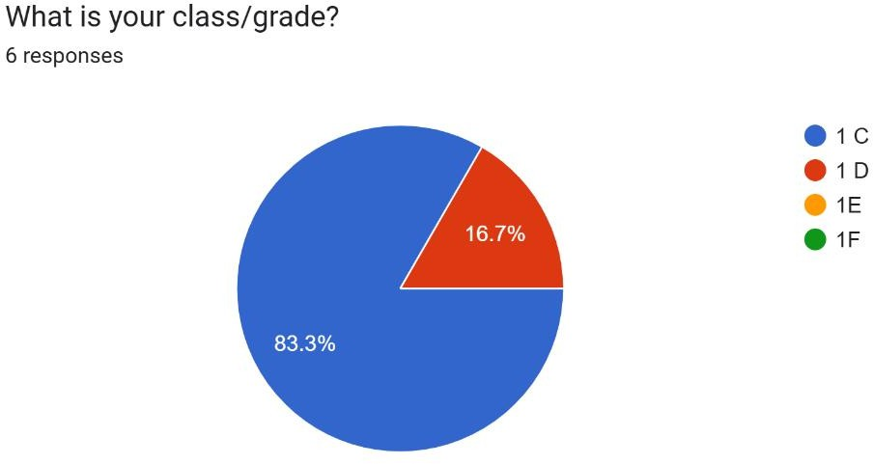

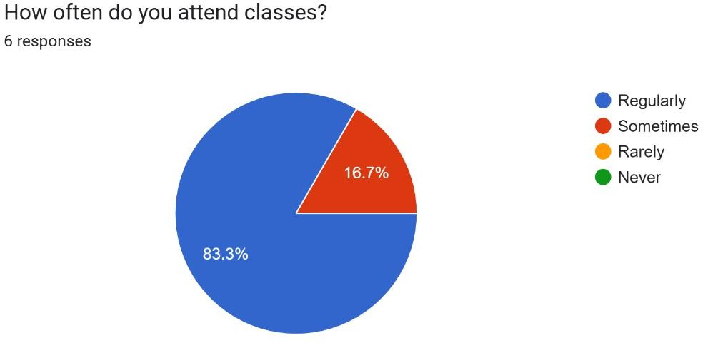

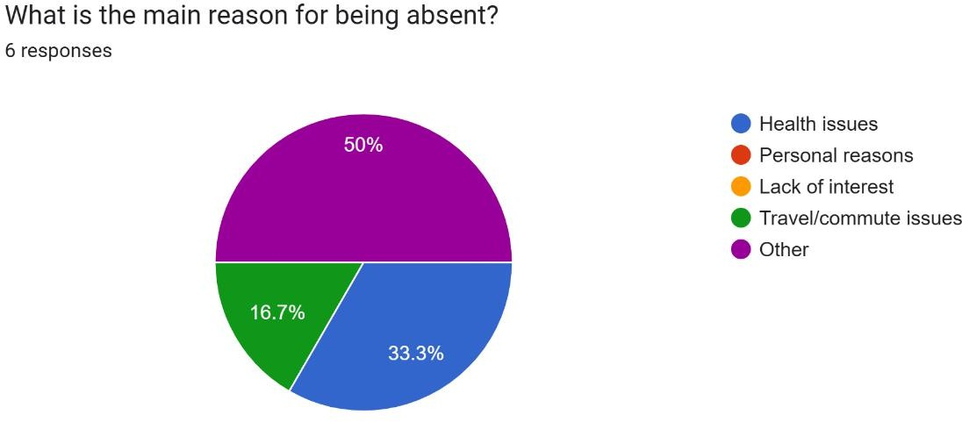

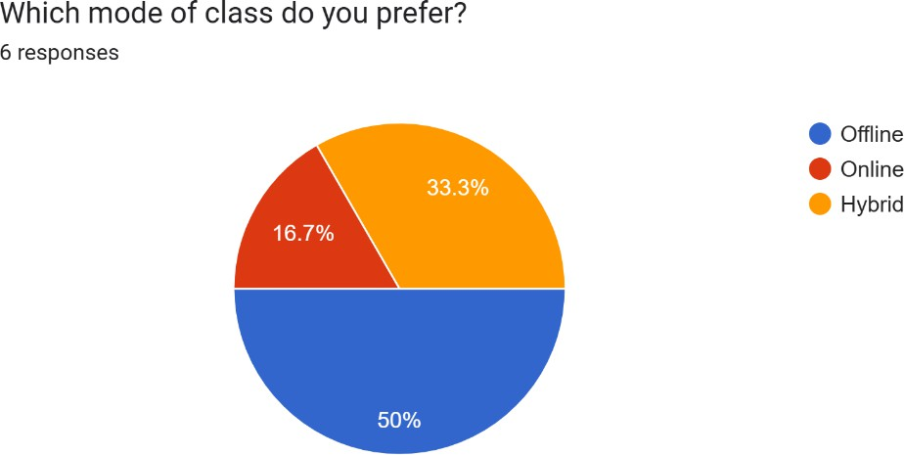

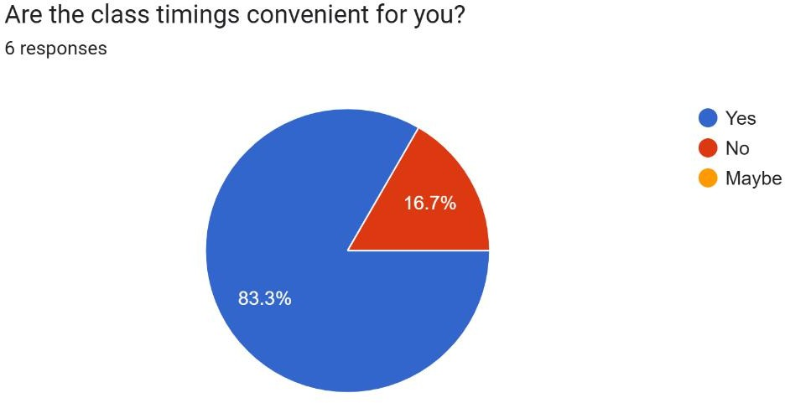

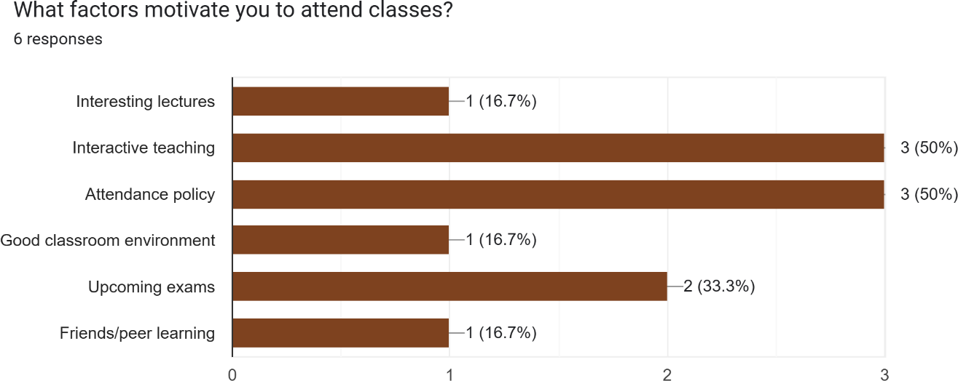

1. **Demonstrate the creation and management of your digital identity.**
   1. Create a social media profile (LinkedIn preferred).
   2. Add a profile photo, short bio, skills, and education details.
   3. Create a simple post about “My Learning Journey in Digital Literacy.”
   4. Change your privacy settings to:
2. Who can see your posts.
3. Who can message you

**Screen Shot of the profile page:**

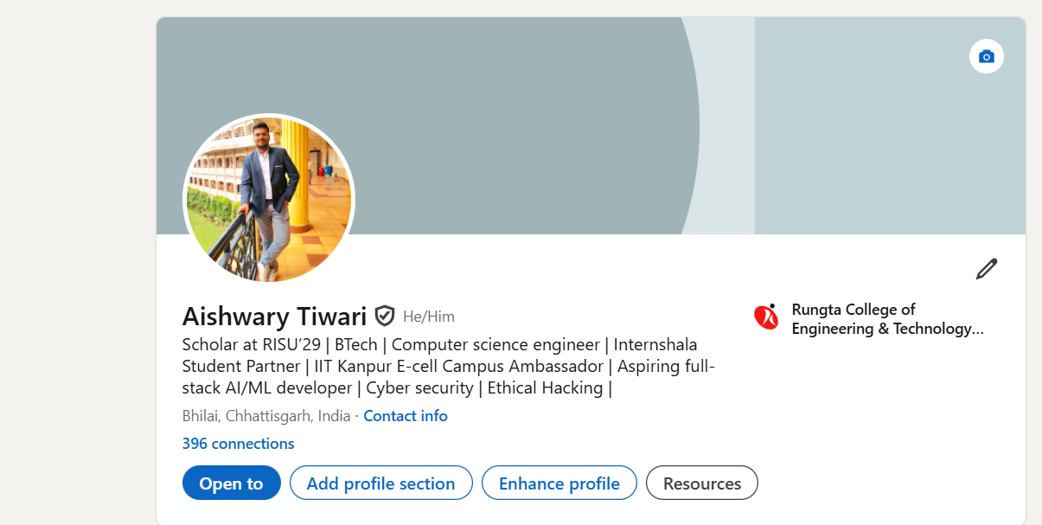

**Screen Shot of the post:**

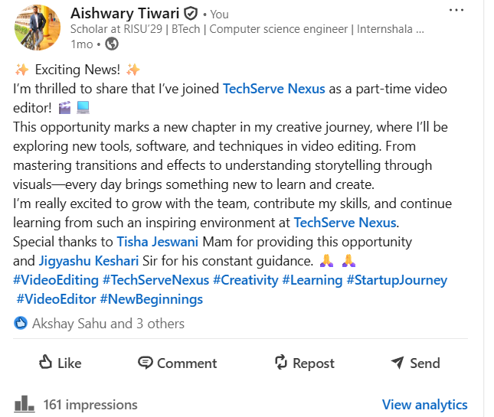

1. **Using Google Drive or OneDrive:**
   1. Create a new folder named “Unit 3 Practical Work”.
   2. Upload 3 different files (PDF, image, document).
   3. Organize them in subfolders: Notes, Images, Assignments.
   4. Share the main folder with your teacher with View Only permission.

**Screen Shot of the google drive:**

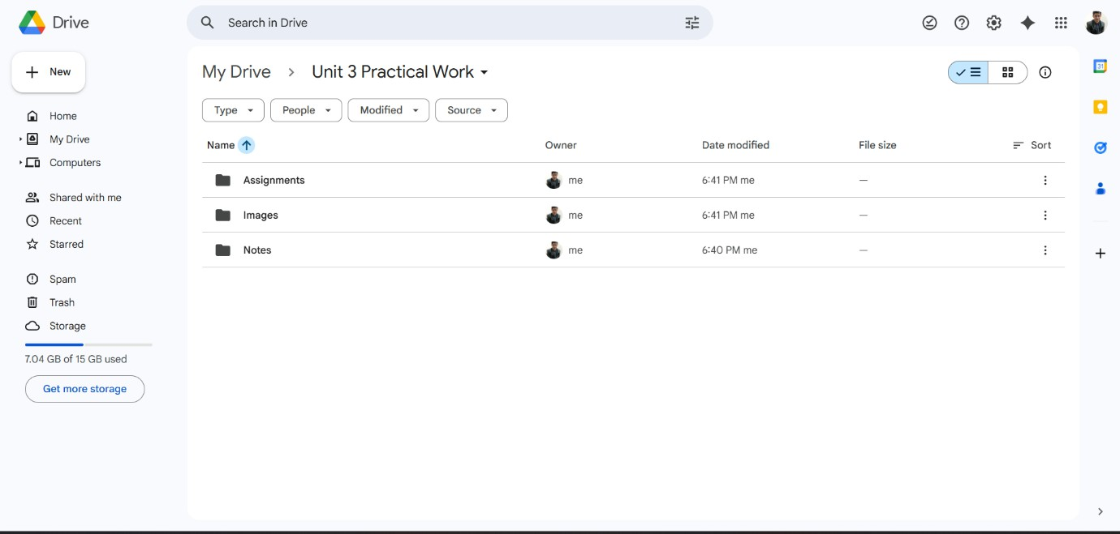

1. **Identify one real phishing email : A final- year student, Aman, receives a LinkedIn message saying:**

“You are shortlisted for a Remote Software Developer role at Google.

Salary: ₹18 LPA.

Pay ₹2,499 as verification fee. Limited seats. Pay now to confirm.”

**ANSWER THE QUESTIONS :-**

# What type of cybercrime is happening here?

Phishing scam (job scam / recruitment fraud).

The attacker is impersonating a company (Google) to steal money.

# List 3 red flags that show it is a scam

* 1. Asking for a payment (₹2,499 “verification fee”) — No real company charges money for hiring.
  2. Too-good-to-be-true offer — Unexpected high salary and instant “shortlisted” without any interview.
  3. Pressure tactics — “Limited seats” and “Pay now to confirm” are classic scam signals.

# What should he do to verify if a job offer is real?

* 1. Check the official company careers website (Google Careers) to see if the job exists.
  2. Verify the recruiter’s profile — look for official company email (e.g., *@google.com*) and check if LinkedIn profile is genuine.
  3. Contact the company directly through official support or HR channels to confirm if the offer is legitimate.

1. **Create a Google Form Quiz with the following requirements:**
   1. Convert the form into a Quiz mode with automatic grading.
   2. Add 5 MCQ questions, each carrying 2 marks.
   3. Add 1 short answer question that requires manual evaluation.
   4. Turn ON the setting:
      1. Limit to 1 response
      2. Shuffle question order
      3. Release marks after manual review
   5. Add a timer add-on (like form presenter) and set up a 10-minute time limit.
   6. Finally, send the quiz link and view the response summary.

**Form:**

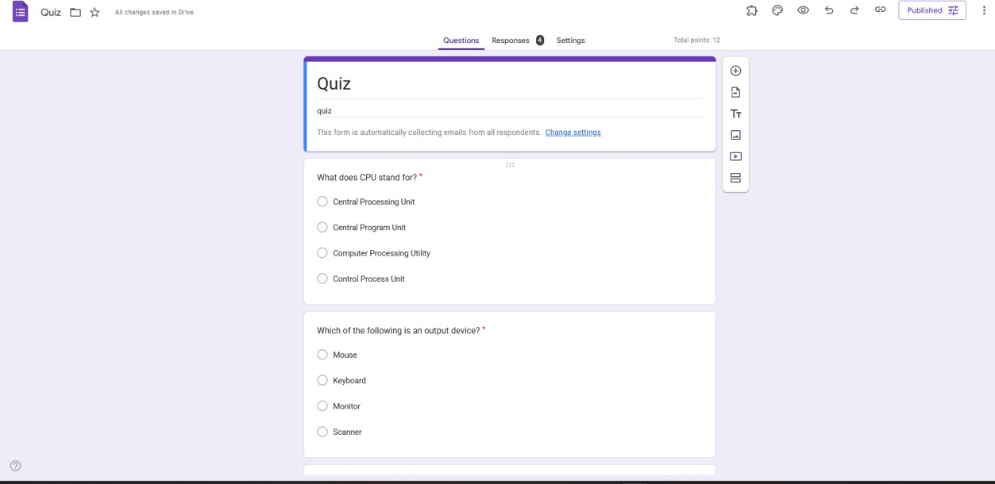

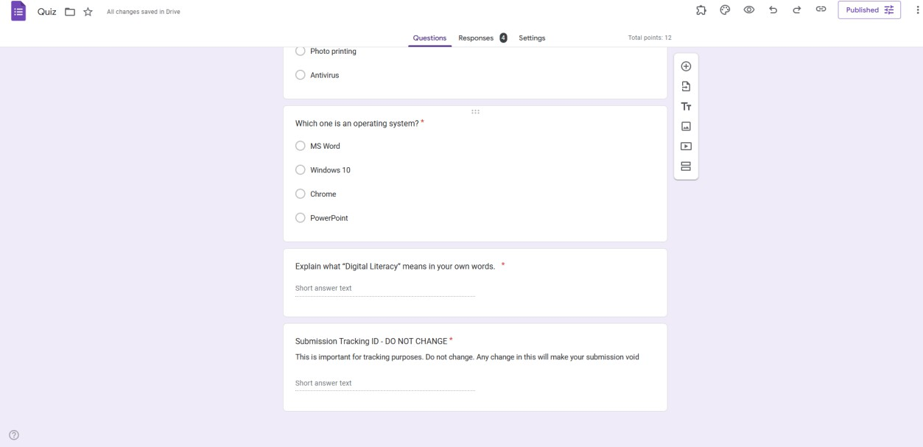

**The Response charts:**

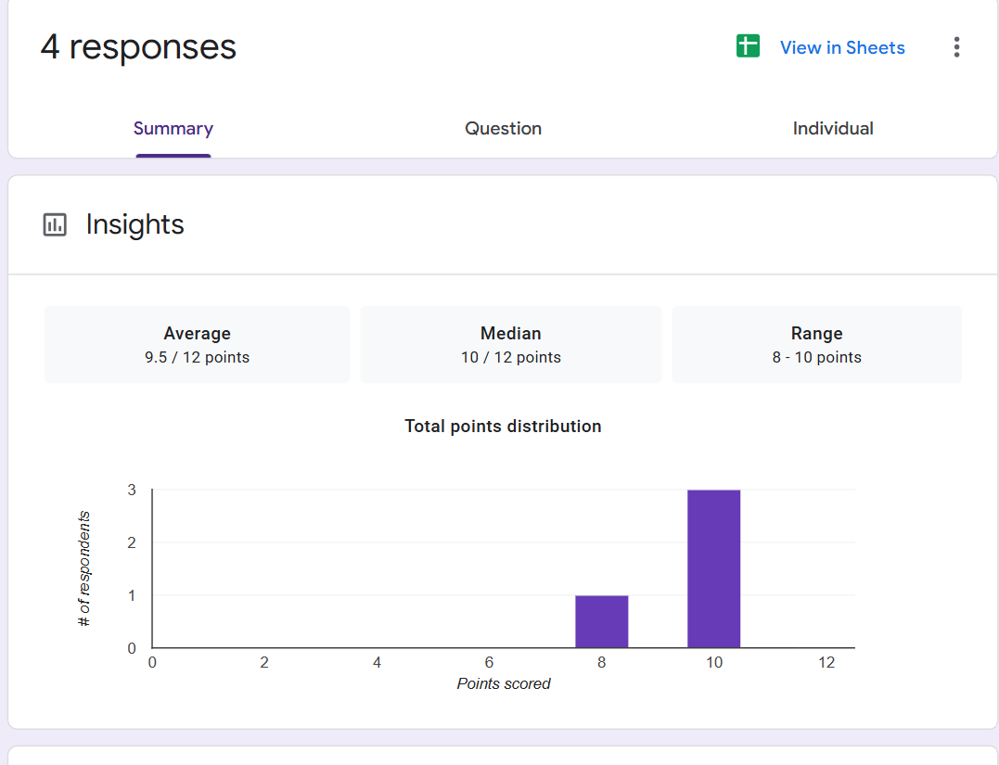

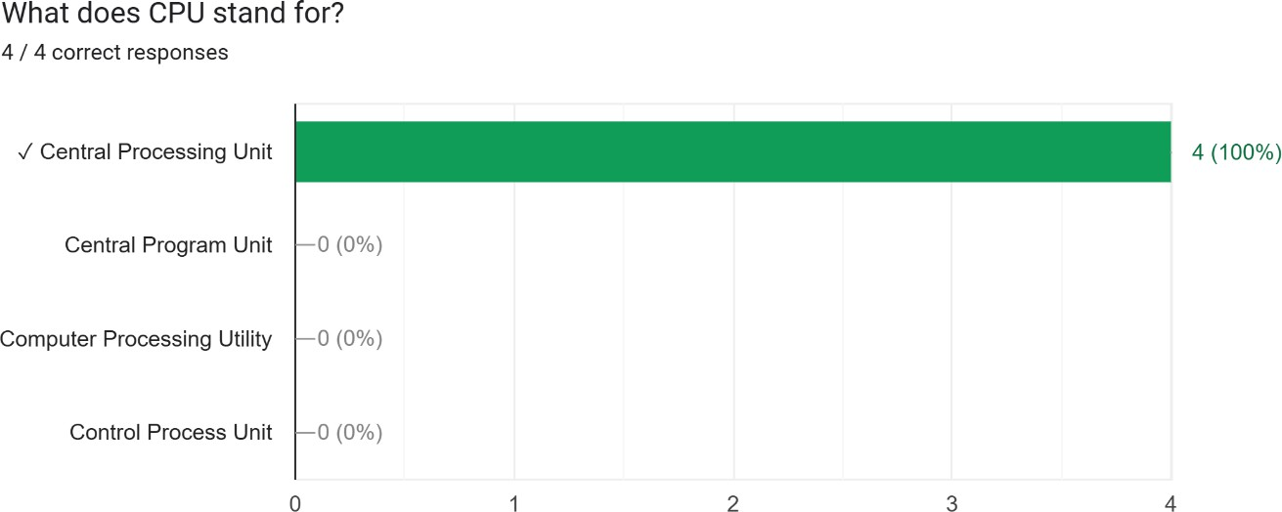

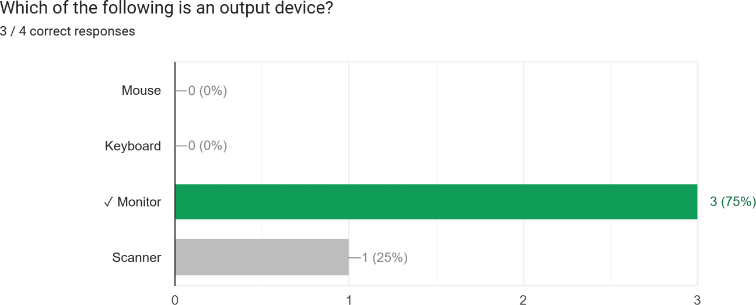

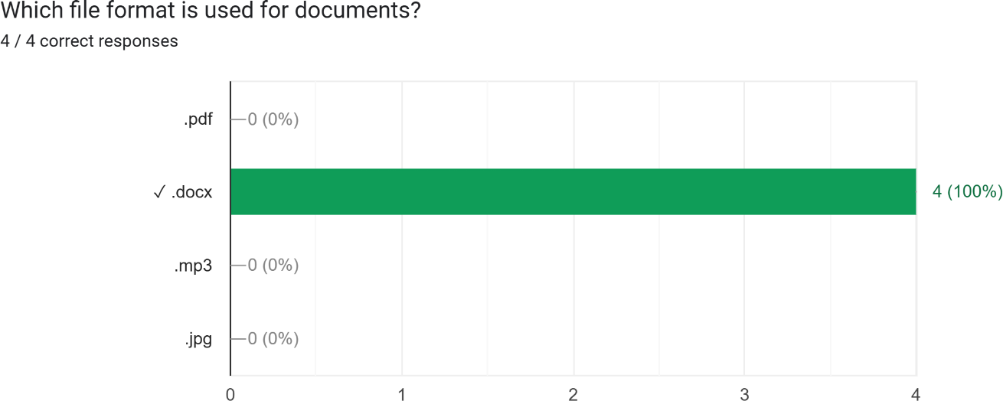

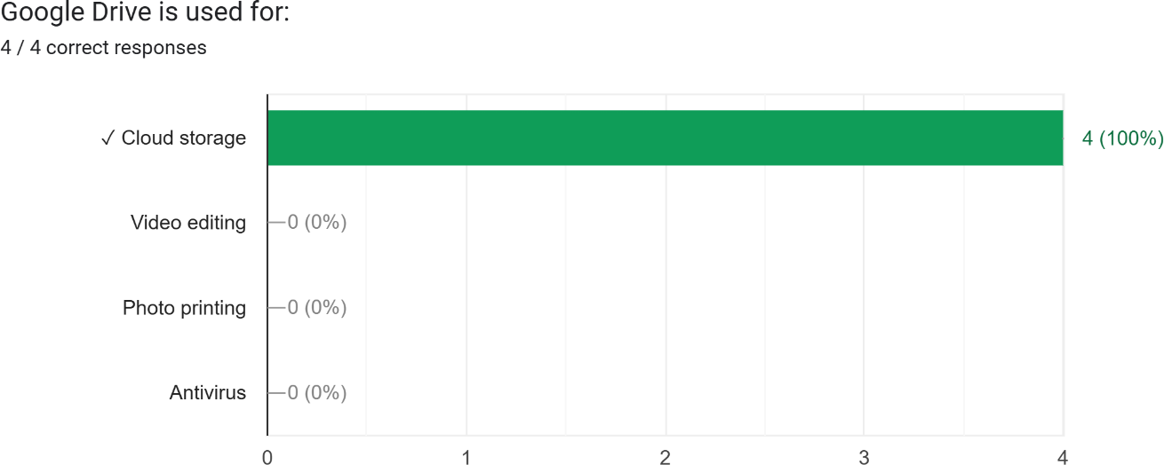

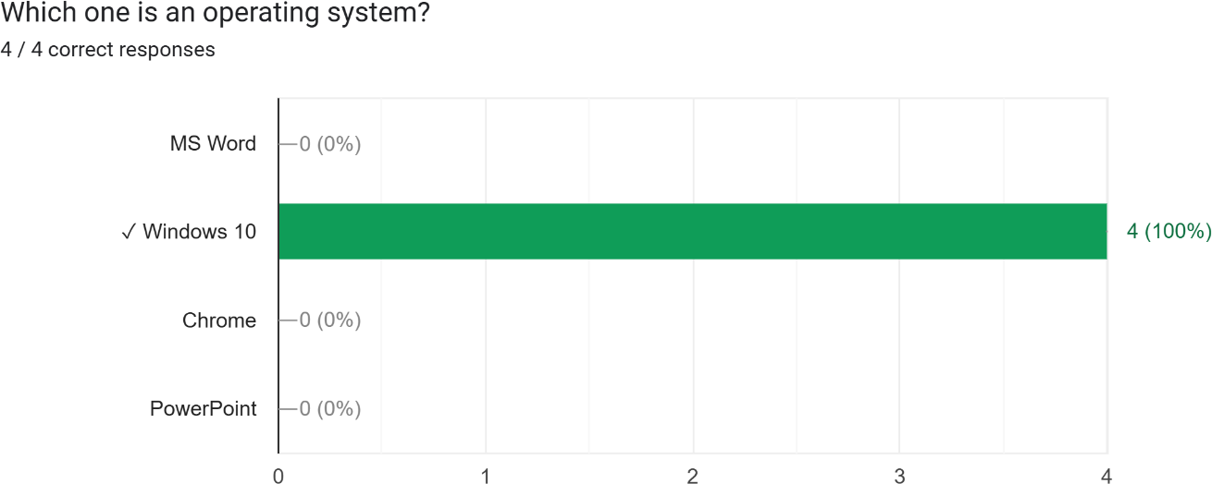

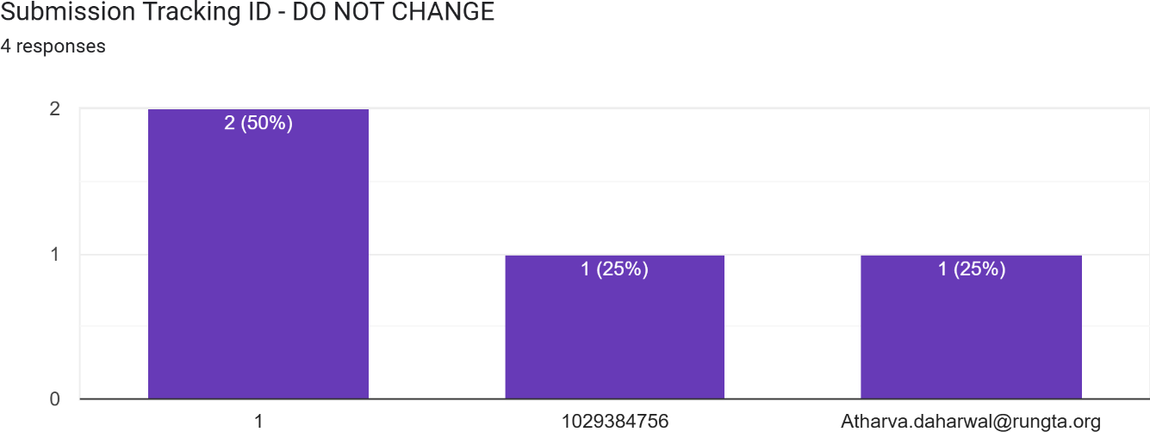

1. **Ask ChatGPT OR Google Gemini to generate a 100–120 word paragraph on:**

“Is online learning better than offline learning for college students?”

* 1. Run the AI-generated text through Grammarly and any plagiarism-check tool.
  2. Now manually search online to check if similar sentences exist on blogs or articles.
  3. Identify 2–3 biased statements in the AI answer, such as:
     1. Over-generalizations
     2. One-sided opinions
     3. Unproven claims
  4. Rewrite the entire paragraph in a neutral and balanced way, using AI only for grammar suggestions.
  5. Submit 3 screenshots:
     1. Plagiarism check result
     2. Grammarly suggestion page
     3. Original AI paragraph vs your rewritten unbiased version

**AI-Generated Paragraph**

Online learning offers college students flexible schedules and

access to a wider range of learning resources. It allows students to revisit recorded lectures, manage their time better, and reduce travel-related expenses. For students with part-time jobs or personal commitments, online platforms can make learning more convenient. However, online classes may limit face-to-face

interaction, hands-on activities, and immediate academic support. On the other hand, offline learning provides a structured environment, direct communication with teachers, and better engagement in practical sessions. Ultimately, the effectiveness of either mode depends on course requirements, technological

access, and individual learning preferences.

**Biased or Over-generalised Statements Identified**

1. “Online learning offers… access to a wider range of resources” — may not be true for all colleges.
2. “Online platforms can make learning more convenient” — convenience differs for every student.
3. “Offline learning provides better engagement in practical sessions” — depends on subject and teaching quality.

**Neutral and Balanced Rewritten Paragraph**

Online and offline learning each offer useful advantages for college students, and their effectiveness varies by subject and learner. Online classes allow flexible scheduling, easy access to

digital materials, and the option to revisit recorded content, which may help some students manage academic and personal responsibilities. In contrast, offline learning provides regular

classroom structure, direct interaction with teachers, and

smoother support for activities that require physical presence.

Both modes can be effective when course design, resources, and student needs are well supported. The best choice depends on factors such as technology access, learning style, course type,

and individual preferences.

1. **To compare AI-generated content with student-created content and understand limitations of AI.**
   1. Write a 100–150 word paragraph on the topic: “Will AI replace jobs or change them?” (This must be written by the student.)
   2. Ask any AI tool (ChatGPT/Gemini/Copilot) to write the same topic.
   3. In your practical copy, create a Comparison Table with the headings:
2. Human-Generated Content
3. AI-Generated Content

# Human-Generated Paragraph

The impact of AI on jobs is becoming one of the most debated topics today. While some people believe AI will replace many roles, it is more accurate to say that AI will change the nature of work rather than remove it entirely. Routine and repetitive tasks may be automated, but new jobs will emerge that require human judgment, creativity, and emotional intelligence. Industries like healthcare, education, and customer service will still depend on people for decision-making and personal interaction. At the same

time, workers will need to learn new digital skills to work alongside AI tools. Overall, AI is likely to transform jobs, not eliminate them, and the future workforce will need to adapt continuously.

# AI-Generated Paragraph

Artificial intelligence is unlikely to fully replace human jobs, but it will significantly reshape the way many industries operate. AI systems are efficient at handling repetitive tasks, data analysis, and large-scale automation, which may reduce the need for certain manual roles. However, the technology also creates new

opportunities in fields such as AI development, cybersecurity, data science, and human–AI collaboration. Jobs that require empathy, critical thinking, creativity, and complex problem-solving will continue to rely on human workers. Instead of replacing people, AI is expected to act as a supportive tool that increases productivity and helps employees focus on higher-value work.

Ultimately, the job market will evolve, and workers will need to update their skills to stay relevant.

1. **Comparison Table**

|  |  |
| --- | --- |
| **Human-Generated**  **Content** | **AI-Generated Content** |
| Written in a personal, natural style with more emotion and  opinion. | More structured, formal, and balanced in tone. |
| Focuses on personal interpretation of how AI will  change jobs. | Presents general information and commonly known facts  about AI. |
| Uses simpler vocabulary and  human-like reasoning. | Uses polished vocabulary and  complex sentence structure. |
| Shows individual perspective and slight bias. | Shows neutral, fact-based  explanations with less personal voice. |

1. **Create a new NotebookLM project titled: “My Chapter Revision Notes.”**

**The screen shot of the project**

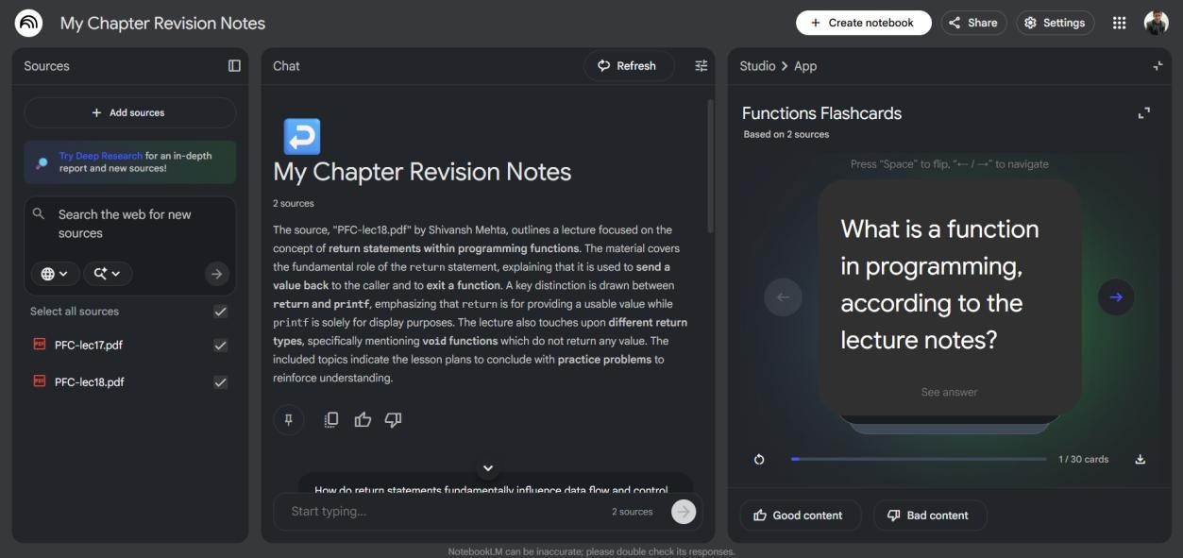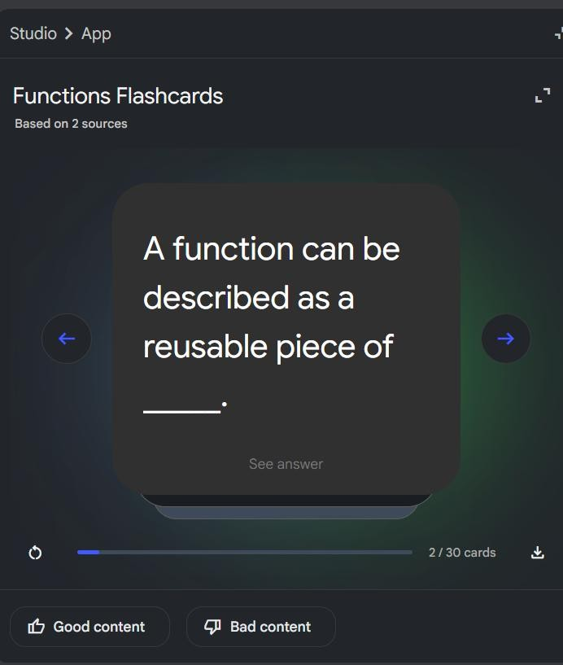

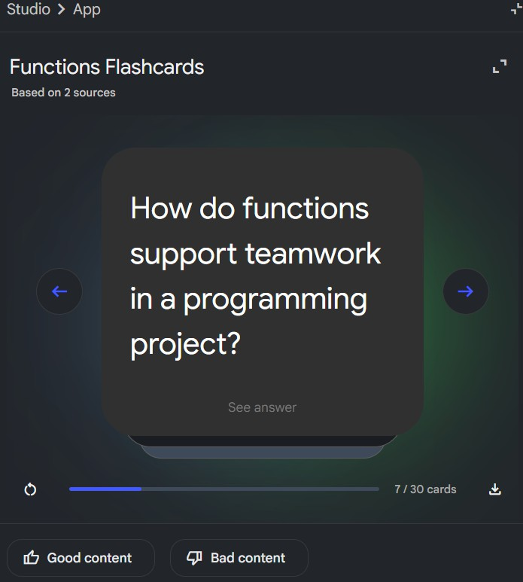

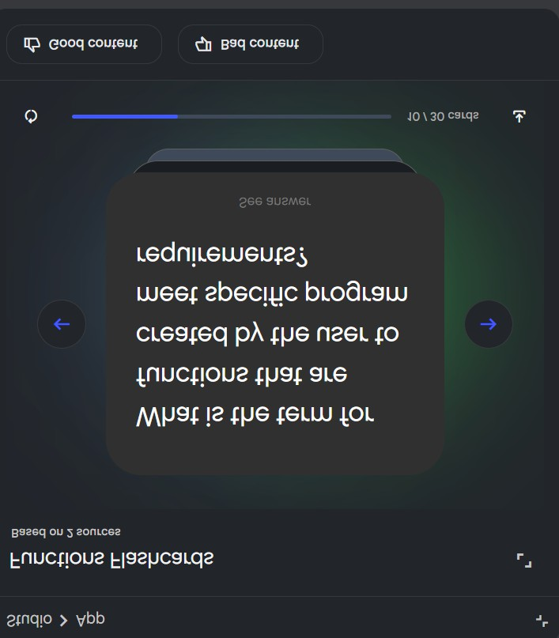

**Practical 13 : Excel Student Result Management**

**[Student Data]**

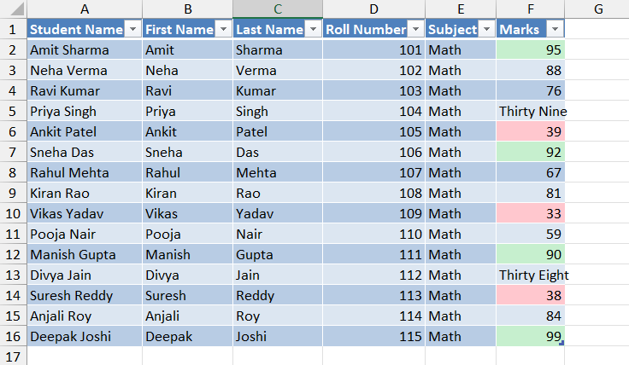

**[Analysis]**

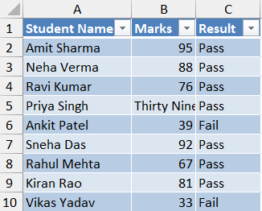 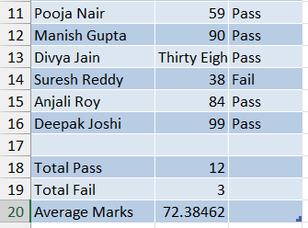

**[Charts]**

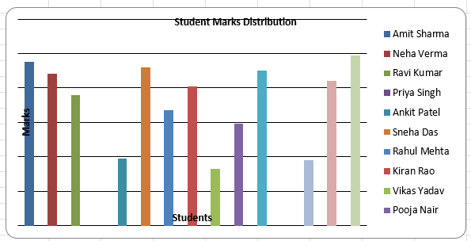 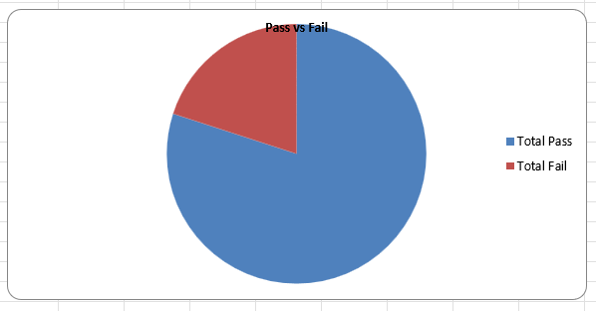

**Practical 14 : Sales Data Workbook**

**[Sales Data]**

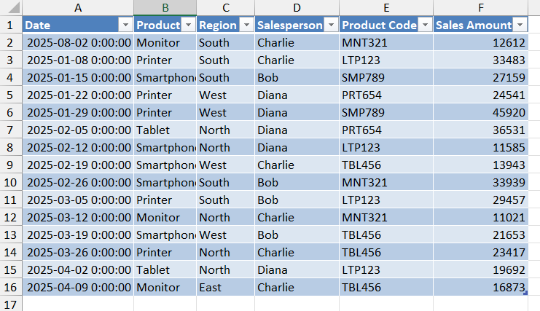

**[Analysis Data]**

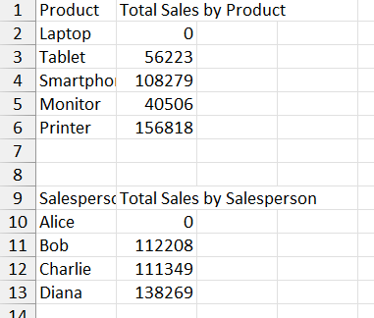  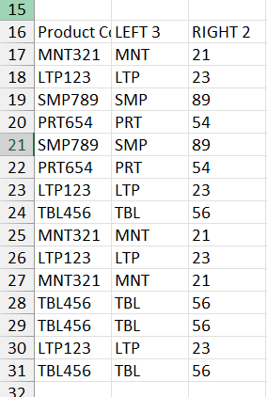

**[Charts]**

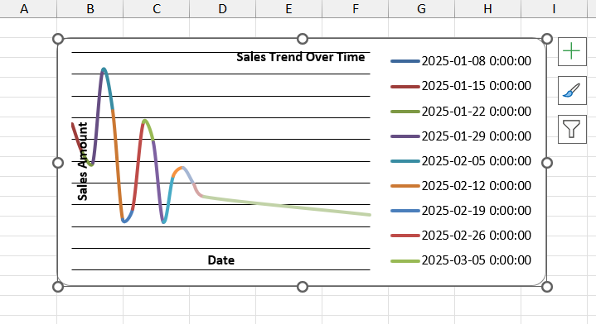

**Practical 15 : Personal Financial Tracker**

**[Expenses]**

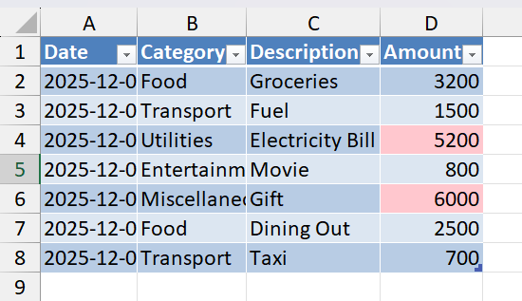

**[Budget VS Actual]**

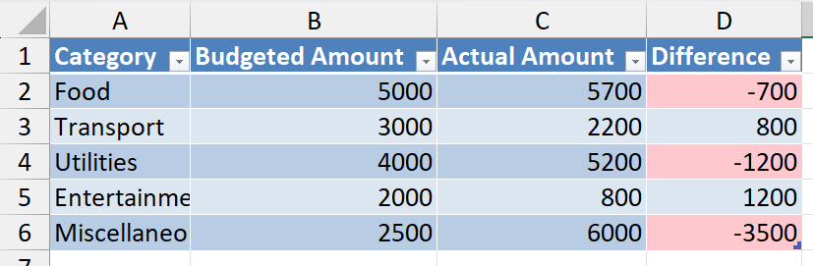

**[Charts]**

